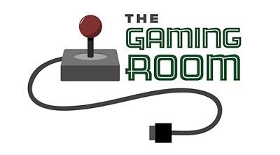

Win, Lose or Draw

CS 230 Project Software Design Template
Version 1.0

Table of Contents

1.CS 230 Project Software Design Template 1
Table of Contents 2
Document Revision History 2
Executive Summary 3
Requirements 3
Design Constraints 3
System Architecture View 3
Domain Model 3
Evaluation 4
Recommendations 5
2.Operating Platform: <Recommend an appropriate operating platform that will allow The Gaming Room to expand Draw It or Lose It to other computing environments.> 5
3.Operating Systems Architectures: <Describe the details of the chosen operating platform architectures.> 5
4.Storage Management: <Identify an appropriate storage management system to be used with the recommended operating platform.> 5
5.Memory Management: <Explain how the recommended operating platform uses memory management techniques for the Draw It or Lose It software.> 5
6.Distributed Systems and Networks: <Knowing that the client would like Draw It or Lose It to communicate between various platforms, explain how this may be accomplished with distributed software and the network that connects the devices. Consider the dependencies between the components within the distributed systems and networks (connectivity, outages, and so on).> 5
7.Security: <Security is a must-have for the client. Explain how to protect user information on and between various platforms. Consider the user protection and security capabilities of the recommended operating platform.> 5

Document Revision History

Version | Date | Author | Comments
1.0 | 11-12-23 | Derek Spaulding | Updated executive summary, design constraints, and the domain model.
1.0 | 11-26-23 | Derek Spaulding | Addressed Development Requirements
1.0 | 12-10-23 | Derek Spaulding | Updated operation recommendations

Executive Summary

The staff at The Gaming Room does not know how to set up their environment for their game Win, Lose or Draw. They wish to have a web-based app capability streamlined into the environment. The game itself is teams will compete with guessing what are the images being rendered to them as clues. There are four rounds, each lasting one minute. It takes the images 30 seconds to fully render from the start of the round. If the team doesn't guess correctly in the time, the other teams are allowed one guess each within the 15 second time limit.
When implementing the game, there needs to be a capability of creating one or more teams, which have multiple members. Game and team names must be unique, and able to check for name availability. Only one instance of the game can exist in memory at any given time.

Requirements

-A game requires the ability to have one or more teams.
-Each team will have multiple players assigned.
-Game and team names must be unique.
-Ability to check for name availability for game and team names.
-Only one instance of a game may be created.

Design Constraints

With web-based applications, a constraint that is applied on all players is the network that connects everyone. If players are dropped due to connectivity issues, there needs to be fail-safe conditions set up in the environment. Also, if the game server manages to lose connection to everyone, then there needs to be a “pause” on the timer in order for the server to resolve connection.
Another constraint is the size of memory in a server. When the game is fully developed, size must be measured to scale how many games can run on a single machine. There may be memory issues if too many games are created on one server at any given time. The ability to send the game creating to another server needs to be implemented.
Performance should also be analyzed in testing to also scale how many games should be allowed on a system. If too many games are going at once, and the server is rendering images between all those games server-side, then there may be a bottleneck in the processor when parsing all of that at one time.
The size of all images should be scaled to a smaller image at the start of a game. This will allow rending to parse faster and is less intensive on the CPU of the server. The image should be readable on all devices that may be used to play, (i.e. mobile phones, computers, smart tv's).
The singleton pattern will be used in game creation to ensure each game instance is unique. This can be abstracted into one function that maintains the ID's and increments the ID after each instantiation.

System Architecture View

Please note: There is nothing required here for these projects, but this section serves as a reminder that describing the system and subsystem architecture present in the application, including physical components or tiers, may be required for other projects. A logical topology of the communication and storage aspects is also necessary to understand the overall architecture and should be provided.

Domain Model

In the UML diagram below, we start with our ProgramDriver class which holds the main function. This class uses the SingletonTester class, which has the testSingleton() function. This function creates a new game session. The GameService class creates an instance of itself, then saves the reference of itself within the default constructor. Then, when the testSingleton() function creates a new GameService object, the reference is passed by the .getInstance() function of the GameService class. This is the singleton pattern and prevents multiple GameService distributors to be created, which may cause collisions of unique ID's of teams, names, and games.
From here, the GameService can create Game objects from the GameService.addGame(name) function. Then, it makes a subsequent call to the .getGame(string name) function. The way the function work is first it creates a null pointer to a Game class. By using an iterator pattern, the GameService iterates through the “games” array list and checks to see if there is already a game taking place with that unique name. If it is not there, then a new one gets created, added to the array list, the nextGameId is passed into the creation of a new game object while incrementing it after, and the game object reference is returned.
The Game class requires for it's constructor a name and ID to be passed into it. This is only done through the GameService singleton. This ensures that there is only one service handles the instances of each game. The Game object then uses the addTeam function to generate a team, with the requirement that a name gets passed into it. The Game class saves an array list of teams. When a team gets added, first an iterator is used to check if the name exists. It will loop until a unique name is given for the addition of a team. It will also assign a unique id to that team.
When the team is created, players are added using the addPlayer function. The list of players are saved in the Team class, and gets updated as more players are added. The Team class maintains the unique id's that are given to new players.
The Entity class holds all the common behaviors of the Game, Team, and Player classes. When each class gets instantiated, those three classes will “extend” the entity class and assign it the variables it was passed on their creations. This utilizes the technique of Object-Relational Mapping used in object-oriented programming design. The entity class is considered the “parent” class.

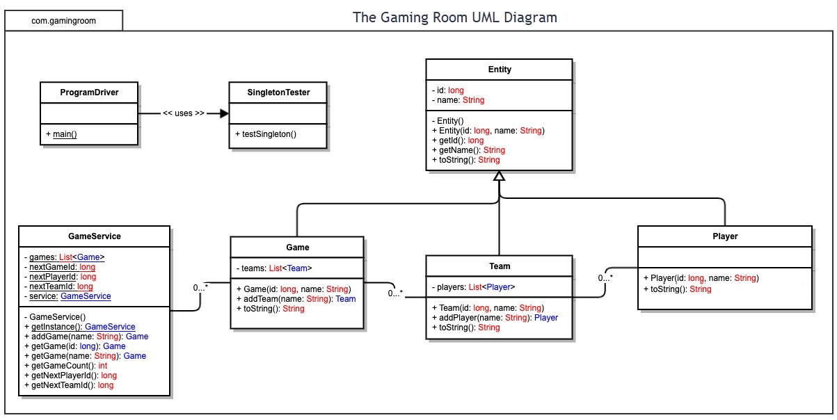

Development Requirements | Mac | Linux | Windows | Mobile Devices
Server Side | On the server-side, Mac is not known for being utilized for servers. It is generally used if the product is utilized only in Apple-based suites. The game being designed is to be used by all platforms. Licensing via “Mountain Lion” is about $500. | Linux is an open-source operating system. The operating system may be tailored for optimal distribution of media for the game. The drawback is that it requires more knowledge in maintenance and keeping drivers up to date. No licensing required unless support for the system is needed. | Windows is a general middle ground when requiring a server with regular support and a UI that's more user-friendly. Windows systems, however, get targeted by hackers as a lot of the world's data resides on these servers. Licensing costs are incurred for Windows-based servers are about $577. | A mobile device should be considered non-applicable for this particular game server. The only way to utilize this is peer-to-peer connections between a small handful of devices on a localized network.
Client Side | Applications are deployed via the Apple Store. They need to follow the Human Interface Guidelines. Need to program using Objective-C or Swift. File hierarchy is different from Windows/Linux. It utilizes the Apple File System. | Applications are deployed through the Microsoft Store. Other game distributors may be used to install clients. Windows uses the NTFS file system when considering saving local files. Games developed in this environment are more portable to other systems when developed in C/C++. | Linux-based client require more expertise than Windows/MacOS. Game clients developed for this system in C/C++ may be portable to other platforms easier. There may be a more time required for support across different versions of Linux. Also, maintaining driver dependencies may be required for the media distribution. | Games are distributed among Apple and Google stores. They must adhere to their guidelines to be hosted. Utilizing frameworks for the game may help with transitioning a mobile game to other operating platforms, if the design starts with mobile. Developing from other platforms into a mobile solution may require more time, as the devices are more constrained on hardware.
Development Tools | Languages that MacOS supports for developing applications are Objective-C and Swift. IDE used for coding is Xcode, which also designs UI. $99 app registration fee is incurred for distribution. | Languages that may be used for Windows is C/C++/C#, Java, Javascript, Rust, Python, and more. IDE's include JetBrains suite and Visual Studio. Licensing can vary from $600-800 for Jetbrains, and a subscription based model for Visual Studio. | Languages include: C/C++, Python, Java, Go, and Rust. IDE's include Visual Studio, Eclipse, as well as Atom and Sublime Text. Atom is free, while Sublime costs $80. | For Apple devices, Xcode with Objective-C and Swift are used. $99 app registration fee is incurred for distribution. For AndroidOS, Android Studio IDE with Java or Kotlin. $25 licensing fee for distribution.

Recommendations

Analyze the characteristics of and techniques specific to various systems architectures and make a recommendation to The Gaming Room. Specifically, address the following:

- Operating Platform: For the server-side, the operating systems that should be used would have to be either Linux or Windows. If The Gaming Room's requirements is to have low training requirements of personnel, I recommend Windows. They are a more abstracted server suite and may only require someone with a certificate in it. The downside is the pricing. However, if The Gaming Room wishes to have a static server with little to no upkeep, then Linux should be used. The initial cost of training or hiring someone to install the servers may be higher, but since the server system won't be needing to update once in place, this should be the choice to make. However, if there are plans of expanding on the Draw It or Lose It game to incorporate more features, it may prove to be more challenging.

- Operating Systems Architectures: The system architecture for this game should utilize the Client-Server architecture. Using the singleton pattern, a game service on the server side handles the creation and management of all game services. This makes sure there are no collisions from within the game's data files and instructions. Processes on the back end should incorporate a Internet Relay Chat, a scoring process, and string checking for guesses. All data being transferred between client and server should utilize RESTful architecture.

- Storage Management: The storage of all images that Draw It or Lose It should be saved in different resolutions before the game servers go live. This will lighten the load on the back end processing so that the game servers don't have to actively render and subsequently serve the images to users of the game application on the client end.

- Memory Management: For Draw It or Lose It, based on the amount of rounds a game lasts for at a maximum, there should be enough image sets loaded into RAM to serve for the games. Depending on how much memory The Gaming Room decides to incorporate into their servers will dictate how to load these files to serve to clients more quickly. If memory efficiency is a must, then each game that gets created utilizes the previously created game's images with one image set removed and another one added. The order of the images may be shuffled to help randomize the games and prevent cheating. This will help the scalability of how many games may operate on one server, and one could predict how many maximum games can be run at a time.

- Distributed Systems and Networks: With the client-server architecture, Draw it or Lose it may be portable to a wide variety of devices using web data transfer. A core functionality should be developed for the game, such as sending REST requests between the game client and the server. Some of these functions include chatting in the game lobby, sending a “guess” string to the server, and receiving the rendered image sets. Then, the way each operating platform handles things like graphics display, input methods, and network may be developed separately. Since Draw it or Lose it is a timed game that requires input, a lag ping should be sent to every user of the application as the game progresses. This will ensure that users are connected at all times. However, if a user reaches a certain threshold of time in a single round due to network inactivity, they may be removed from the match. This ensures games do not stall on a single match, and other users may progress to another game if they want.

- Security: Since the communication between client and server is using a RESTful style architecture, it is easier to keep data security safe. The server-side should never store any data on any user that may be sensitive. Things like IP addresses and web communications should only be stored when initializing the communication between client and server. Depending on the performance of the servers, the best case scenario is to dump the user information whenever the functionality of every REST call gets made. Next, keeping an anti-virus installed with updated virus definitions should be ran on the server-side. Also, making sure a firewall is up on the operating system will prevent access to the server via another port other than what the game is allowed to communicate through. Linux and Windows both come with one that may be configured to only allow communication through a specific port with the game. So, all communication would be monitored on that port and only API calls that are allowed may manipulate anything on the server. If there are accounts that are to be created for the game that require sign up, a different authentication server should be made and communicate with the game server directly to ensure data security. For example, a user authenticates their user info to the server and gets a token of sign-in. The sign-in token gets passed from the authentication server to the game server to let it know that the user's IP address is cleared for playing the game while keeping their private information abstracted away from the game server. Then, the only available security threat that would ever be apparent would have to be at the physical location itself.

